SIT223/753 – HD Task - Answer Sheet
- A link to the demo video

- Provide a link to your GitHub repository containing the Jenkins pipeline script. Please ensure that your marking tutor has been granted appropriate access
https://github.com/s225645819/SIT753_7_3HD.git

- Specify how many stages you have implemented
I have successfully implemented all 7 stages with full automation and smooth transitions between stages.

- A brief description of your project and the technologies used.
To demonstrate a comprehensive, production-like CI/CD pipeline, I engineered a custom Node.js Express API rather than a simple static website. The application features a dedicated /health endpoint designed specifically for live system monitoring. The technology stack includes Node.js/Express for the backend architecture, Jest and Supertest for automated unit and integration testing, Jenkins for pipeline orchestration, SonarCloud for continuous code quality inspection, and Discord Webhooks for real-time monitoring and incident alerting.

- A screenshot of your Jenkins pipeline.
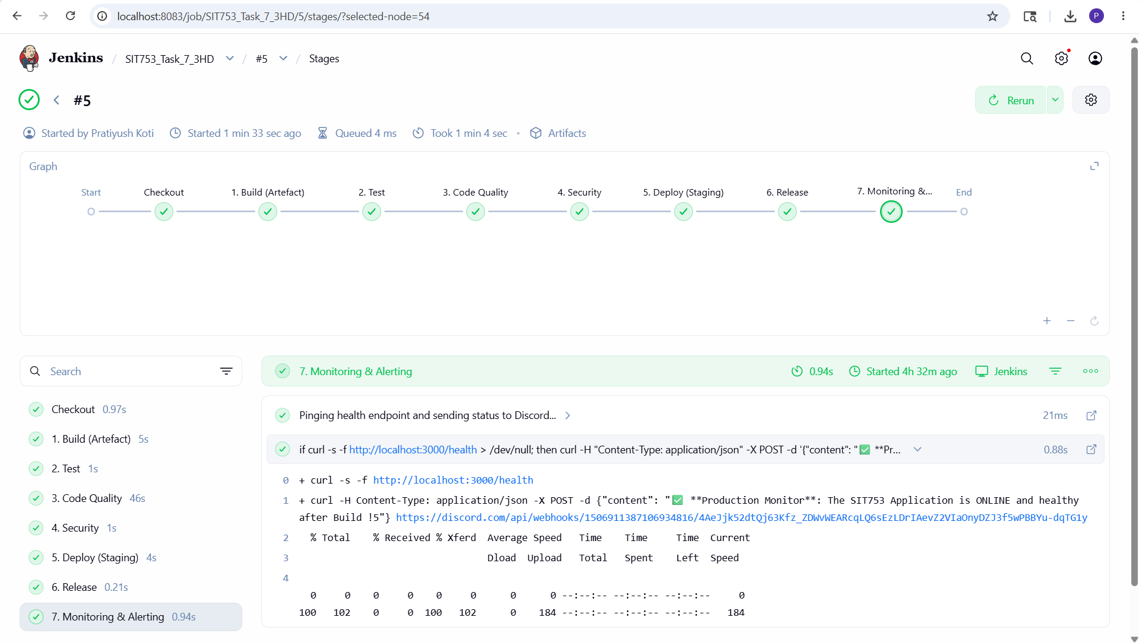

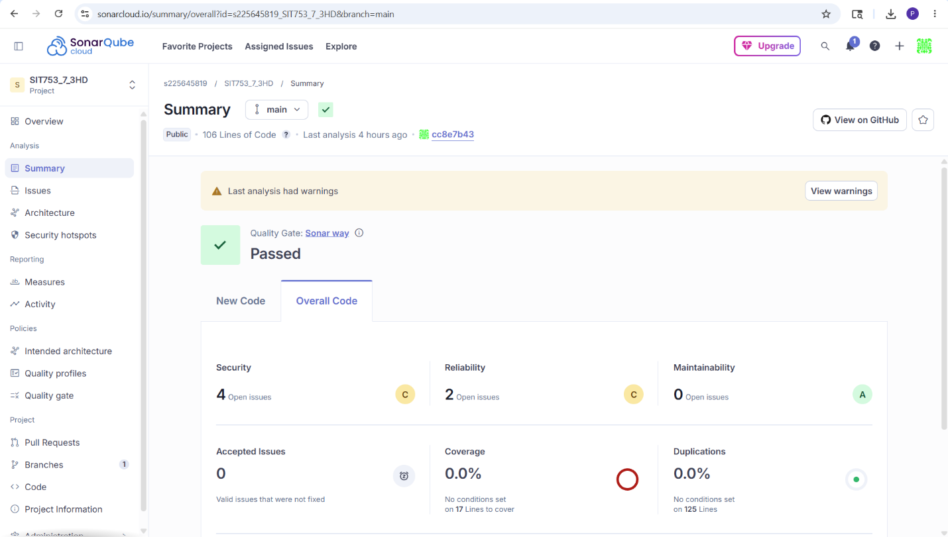

- A brief description of each stage of your pipeline including the used frameworks/tools.
  - Build:
Jenkins automatically installs all project dependencies and packages the application into a secure, version-controlled .tar.gz artifact. The build is dynamically tagged using the Jenkins environment variable (app-release-v${BUILD_NUMBER}.tar.gz) to ensure version traceability. Tools: Node Package Manager (npm), Bash (tar).

  - Test:
This stage executes an automated Jest testing suite against the application's endpoints. It acts as a strict quality gate; configured with clear pass/fail gating, the pipeline will immediately halt if any unit test fails, ensuring broken code never reaches the deployment phase. Tools: Jest, Supertest.

  - Code Quality
The pipeline seamlessly connects to SonarCloud to perform continuous code inspection. It analyzes the codebase against advanced configurations, checking for code smells, bugs, and maintainability issues. If the codebase fails the defined Quality Gate thresholds, the pipeline is blocked. Tools: SonarCloud, npx sonar-scanner.

  - Security
For proactive security handling, the pipeline scans the application's entire dependency tree for known vulnerabilities (CVEs). Currently, the scan returns 0 vulnerabilities. If critical issues are identified in the future, they are mitigated by immediately updating the package version in the package.json file. Tools: npm audit.

  - Deployment
This stage executes an end-to-end automated deployment to a local staging environment. Using best practices, the pipeline gracefully terminates any older server processes running on the designated port before booting up the new Node.js server in the background. Tools: Bash (fuser, nohup).

  - Release
The pipeline promotes the successfully deployed application by securely archiving the tagged, versioned artifact (app-release-v*.tar.gz) within Jenkins. This ensures the release process is repeatable and provides a permanent backup for immediate rollback support if needed. Tools: Jenkins ArchiveArtifacts.

  - Monitoring
To provide a fully integrated system with meaningful alert rules, Jenkins executes a live health check by pinging the deployed application's /health endpoint. If the app is healthy, a "Production ONLINE" webhook is sent to the engineering team's Discord. To satisfy the incident simulation requirement, if the application crashes, the pipeline catches the failed HTTP response and instantly fires a "CRITICAL ALERT: Application DOWN" notification. Tools: cURL, Discord Webhooks API.

